## Anjuman-I-Islam

**M.H. Saboo Siddik Polytechnic**



**Prepared by:**

**ENTREPRENEURSHIP DEVELOPMENT (EDE) MICROPROJECT COMPUTER ENGINEERING DEPARTMENT**

**CO-6I TITLE: FOOD STALL**

**YEAR: 2023-24**

* 210418: Hassaan Shaikh
* 210444: Mohiuddin Merchant
* 210454: Azlan Shaikh
* 210451 : Abdurrahman
* 210455 : Oaish Qazi

**Under the guidance of**: Prof. Talha Munshi, Prof. Yahya Ansari



# MAHARASHTRA STATE BOARD OF TECHNICAL EDUCATION

## Certificate

This is to certify that Mr. Hassaan Shaikh Roll no. 210418 of sixth semester of Diploma in Computer Engineering of institute M.H. Saboo Siddik Polytechnic(code: 0002) has completed microproject satisfactorily in the subject: EDE (22032) for the academic year 2023-24 as prescribed in the curriculum.

Place: Byculla, Mumbai Enrolment no:2100020085 Date: Exam seat no:

|  |  |  |
| --- | --- | --- |
| **Signature** | **Signature** | **Signature** |
| **Project guide** | **H. O. D** | **Principal** |

SEAL OF INSTITUDE



# MAHARASHTRA STATE BOARD OF TECHNICAL EDUCATION

## Certificate

This is to certify that Mr Mohiuddin Merchant Roll no. 210444 of sixth semester of Diploma in Computer Engineering of institute M.H. Saboo Siddik Polytechnic(code:0002) has completed microproject satisfactorily in the subject: EDE (22032) for the academic year 2023-24 as prescribed in the curriculum.

Place: Byculla, Mumbai Enrolment no:2100020106 Date: Exam seat no:

|  |  |  |
| --- | --- | --- |
| **Signature** | **Signature** | **Signature** |
| **Project guide** | **H. O. D** | **Principal** |

SEAL OF INSTITUDE



# MAHARASHTRA STATE BOARD OF TECHNICAL EDUCATION

## Certificate

This is to certify that Mr.Azlan Ahmed Roll no. 210454 of sixth semester of Diploma in Computer Engineering of institute M.H. Saboo Siddik Polytechnic(code:0002) has completed microproject satisfactorily in the subject: EDE (22032) for the academic year 2023-24 as prescribed in the curriculum.

Place: Byculla, Mumbai Enrolment no:2100020093 Date: Exam seat no:

|  |  |  |
| --- | --- | --- |
| **Signature** | **Signature** | **Signature** |
| **Project guide** | **H. O. D** | **Principal** |

SEAL OF INSTITUDE



# MAHARASHTRA STATE BOARD OF TECHNICAL EDUCATION

## Certificate

This is to certify that Mr.Oaish Qazi Roll no. 210455 of sixth semester of Diploma in Computer Engineering of institute M.H. Saboo Siddik Polytechnic(code:0002) has completed microproject satisfactorily in the subject: EDE (22032) for the academic year 2023-24 as prescribed in the curriculum.

Place: Byculla, Mumbai Enrolment no:2100020108 Date: Exam seat no:

|  |  |  |
| --- | --- | --- |
| **Signature** | **Signature** | **Signature** |
| **Project guide** | **H. O. D** | **Principal** |

SEAL OF INSTITUDE



# MAHARASHTRA STATE BOARD OF TECHNICAL EDUCATION

## Certificate

This is to certify that Mr.Abdurrahman Qureshi Roll no. 210451 of sixth semester of Diploma in Computer Engineering of institute M.H. Saboo Siddik Polytechnic(code:0002) has completed microproject satisfactorily in the subject: EDE (22032) for the academic year 2023-24 as prescribed in the curriculum.

Place: Byculla, Mumbai Enrolment no:2100020112 Date: Exam seat no:

|  |  |  |
| --- | --- | --- |
| **Signature** | **Signature** | **Signature** |
| **Project guide** | **H. O. D** | **Principal** |

SEAL OF INSTITUDE

**ACKNOWLEDGMENT**

We wish to express our profound gratitude to our guide Mr. Talha Munshi Sir and Mr. Yahya Ansari sir who guided us endlessly in the framing and completion of the micro project. He guided us on all the main points in that micro project. We are indebted to his constant encouragement, cooperation, and help. It was his enthusiastic support that helped us in overcoming various obstacles in the micro-project.

We are also thankful to our Principal, HOD, faculty members and classmates of Computer Engineering department for extending their support and motivation in the completion of this micro-project.

Names of Team Members with Roll Nos.

1. Shaikh Hassaan – 210418
2. Mohiuddin Merchant - 210444
3. Abdurrahman Qureshi - 210451
4. Azlan Ahmed - 210454
5. Oaish Qazi - 210455

### Annexure-I

***Microproject proposal***

## Title of microproject: Food Stall

### Aims/Benefits of microproject

To create a unique culinary experience by offering locally sourced, sustainable ingredients crafted into delicious and innovative dishes, catering to the modern palate while promoting community engagement and environmental stewardship.

### Course outcomes addressed

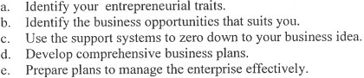

1. **Proposed methodology**
   * To search the information about the project. (Collect relevant data from different sources (books/internet/market/suppliers/experts and others through surveys/interviews etc.).
   * To collect all relevant content / materials to complete the project.
   * To prepare the report of micro project.
   * To deliver presentation/ appear for viva-voice

* Discussion of the given topic among group members.
* Literature survey
* Submission of project proposal
* Analysis of data
* Work divided among group members
* Compilation of content
* Representation
* Editing the content as per the instructions
* Report Preparation
* Viva and presentation

**Annexure-I**

1. **Action Plan**

|  |  |  |  |  |
| --- | --- | --- | --- | --- |
| **Weeks** | **Details of activity** | **Planned start date** | **Planned finish date** | **Name of responsible**  **team members** |
| 1& 2 | Discussions & finalization of topics |  |  |  |
| 3 | Preparation of abstract |  |  |  |
| 4 | Literature review |  |  |  |
| 5 | Submission of microproject proposal(Annexure -I) |  |  |  |
| 6 | Collection of information on given topic |  |  |  |
| 7 | Collection of all relevant contents |  |  |  |
| 8 | Discussion and submission of outline of the project |  |  |  |
| 9 | Analysis/execution of collected data/information and Preparation of prototypes/drawings/charts/graphs/ tables/models/circuits/programs/testing etc. |  |  |  |
| 10 | Compilation of contents of project |  |  |  |
| 11 | Compilation of weekly progress report |  |  |  |
| 12 | Preparation of the project report (Annexure II) |  |  |  |
| 13 | Viva Voce / Delivery of presentation. |  |  |  |

1. **Resources required**

|  |  |  |  |  |
| --- | --- | --- | --- | --- |
| **Sr. no.** | **Name of resources** | **Specifications** | **Qty** | **Remarks** |
| 1. | Desktop | Word | 1 for each |  |

Names of Team Members with Roll Nos.

1. Shaikh Hassaan – 210418
2. Mohiuddin Merchant - 210444
3. Abdurrahman Qureshi - 210451
4. Azlan Ahmed – 210454
5. Oaish Qazi – 210455

Approved by:

Sign of Faculty:

Name of faculty: Prof. Talha Munshi , Yahya Ansari

### Rationale

***Microproject Report***

**Title of Micro-project: Food stall**

### Annexure-II

The rationale for starting a food business can be grounded in several compelling factors: Passion for Food, Identified Market Opportunity, Unique Selling Proposition (USP), Personal Values and Beliefs, Potential for Scalability and Growth, etc. Food businesses have the ability to bring people together and contribute to the social fabric of communities. Entrepreneurs may be motivated by the opportunity to create gathering spaces, support local farmers and producers, or participate in charitable initiatives. Starting a food business allows them to make a positive impact on their community.

### Aims/Benefits of microproject

Starting a food business can offer a range of benefits for entrepreneurs:Creative Expression, Flexibility, Community Engagement, Potential for High Margins. Entrepreneurs in the food industry have the opportunity to promote health and wellness through their offerings. By emphasizing fresh, nutritious ingredients and accommodating dietary preferences or restrictions, they can positively impact the well- being of their customers.Food businesses create employment opportunities, both directly through hiring staff for various roles such as chefs, servers, and managers, and indirectly by supporting suppliers, distributors, and other service providers in the food ecosystem.

Overall, the benefits of starting a food business include opportunities for creativity, flexibility, community engagement, profitability, scalability, diversification, customer loyalty, health promotion, job creation, and legacy building.

### Course outcomes achieved

* 1. Identify your entrepreneurial traits
  2. Identify business opportunities that suits you
  3. Develop comprehensive business plans

### Literature review

All the information was gathered during the project execution & scrutiny was done. All relevant & required information/pictures were added in the project.

### Actual Methodology Followed

We were assigned with the microproject topic and time was assigned to us to complete the project. Project was implemented and finally at last technical report was prepared.

### Actual resources used

|  |  |  |  |  |
| --- | --- | --- | --- | --- |
| **Sr.**  **no.** | **Name of resources** | **Specifications** | **Qty** | **Remarks** |
| 1. | Software | Word. | 1 for  each |  |

1. **Outputs of the microproject**

Our college group had a fun and educational experience planning and running a business stall. We started by choosing what to sell – Khaman Dhokla and Jalebi. Then, we divided tasks like buying ingredients and setting up the stall among ourselves. During the event, we worked together to attract customers and handle sales. It was a great opportunity to learn about teamwork and how businesses operate in real life. We had a lot of fun and gained valuable skills for the future.

Here's a breakdown of the key aspects of our experience:

**Product Selection:** Choosing what to sell is a crucial first step. Your group opted for Khaman Dhokla and jalebi, which likely involved considering factors such as popularity, ease of preparation, and profit margins.

**Task Delegation:** Dividing tasks among group members is essential for efficient operation. Assigning responsibilities such as purchasing ingredients, setting up the stall, marketing, and handling sales ensured that everything ran smoothly.

**Teamwork and Collaboration:** Working together as a team during the event allowed you to attract customers and manage sales effectively. Collaboration fosters creativity and ensures that everyone's strengths contribute to the success of the endeavor.

**Real-world Business Experience:** Running a stall provides valuable insights into the practical aspects of operating a business. From managing inventory and handling transactions to interacting with customers, you gained firsthand experience that can't be replicated in a classroom.

**Personal Development:** Beyond the business aspect, such experiences also foster personal growth. You likely developed skills such as communication, problem-solving, and adaptability, all of which are invaluable in various aspects of life.

Overall, our group's initiative to plan and run a business stall not only provided a memorable experience but also equipped us with skills and lessons that will undoubtedly benefit us in the future.

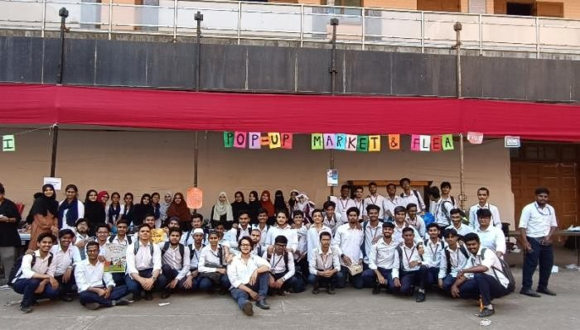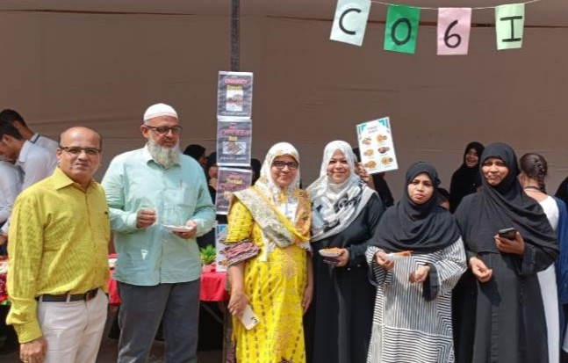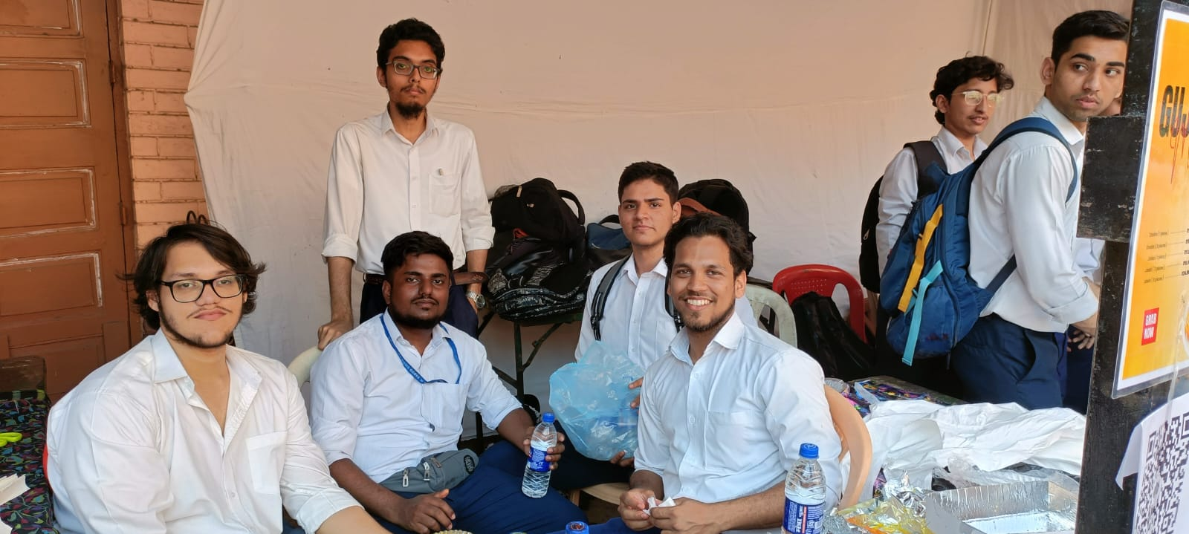

### Skills developed/ Learning outcomes

* Teamwork- Learning to work in team and boost individual confidence.
* Time management- Completion of microproject as scheduled.
* Technical writing- Preparing a report of proposed plan and report.
* Confidence: Confidently, answer the questions asked about the project.

### Applications of this microproject

Food startup businesses can find applications in various areas, including:

1. **Innovation:** Introducing unique food concepts or fusion cuisines to cater to evolving consumer tastes and preferences.
2. **Health and Wellness:** Developing nutritious and organic food options to meet the growing demand for healthier eating alternatives.
3. **Technology Integration:** Utilizing technology for online ordering, food delivery, and personalized customer experiences, enhancing convenience and efficiency.
4. **Sustainability:** Implementing eco-friendly practices such as sourcing local ingredients, reducing food waste, and using biodegradable packaging to appeal to environmentally conscious consumers.
5. **Food Services:** Providing catering services for events, corporate gatherings, and special occasions, offering customizable menus and memorable dining experiences.

**Micro Project Evaluation Sheet**

Name of student: Shaikh Hassaan Enrollment no: 2100020085 Name of programme: Computer Engineering Semester: 6th

Course title: Entrepreneurship Development Code: 22032 Title of microproject: Food Stall

Course outcomes achieved:

* 1. Identify your entrepreneurial traits
  2. Identify business opportunities that suits you
  3. Develop comprehensive business plans

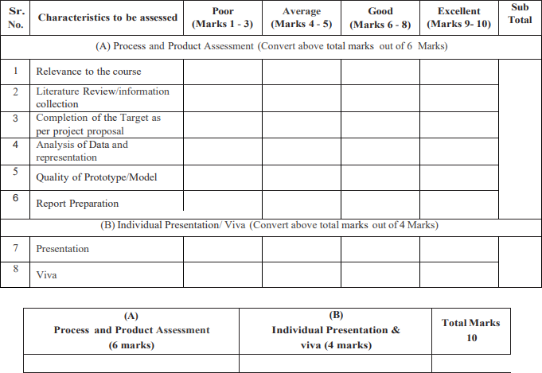

**Comments/Suggestions about teamwork/leadership/interpersonal communication**

**Name and designation of teacher: Dated signature:**

**Micro Project Evaluation Sheet**

Name of student: Mohiuddin Merchant Enrollment no: 2100020106 Name of programme: Computer Engineering Semester: 6th

Course title: Entrepreneurship Development Code: 22032 Title of microproject: Food Stall

Course outcomes achieved:

1. Identify your entrepreneurial traits
2. Identify business opportunities that suits you
3. Develop comprehensive business plans



**Comments/Suggestions about teamwork/leadership/interpersonal communication**

**Name and designation of teacher: Dated signature:**

**Micro Project Evaluation Sheet**

Name of student: Azlan Ahmed Enrollment no: 2100020093 Name of programme: Computer Engineering Semester: 6th

Course title: Entrepreneurship Development Code: 22032

Title of microproject: Food Stall Course outcomes achieved:

* 1. Identify your entrepreneurial traits
  2. Identify business opportunities that suits you
  3. Develop comprehensive business plans



**Comments/Suggestions about teamwork/leadership/interpersonal communication**

**Name and designation of teacher: Dated signature:**

**Micro Project Evaluation Sheet**

Name of student: Abdurrahman Qureshi Enrollment no: 2100020112 Name of programme: Computer Engineering Semester: 6th

Course title: Entrepreneurship Development Code: 22032

Title of microproject: Food Stall Course outcomes achieved:

1. Identify your entrepreneurial traits
2. Identify business opportunities that suits you
3. Develop comprehensive business plans



**Comments/Suggestions about teamwork/leadership/interpersonal communication**

**Name and designation of teacher: Dated signature:**

**Micro Project Evaluation Sheet**

Name of student: Oaish Qazi Enrollment no: 2100020108 Name of programme: Computer Engineering Semester: 6th

Course title: Entrepreneurship Development Code: 22032

Title of microproject: Food Stall Course outcomes achieved:

1. Identify your entrepreneurial traits
2. Identify business opportunities that suits you
3. Develop comprehensive business plans



**Comments/Suggestions about teamwork/leadership/interpersonal communication**

**Name and designation of teacher: Dated signature:**